# Activity 3. Launch a Ping-Pong Ball (ΝΕΜΟ)

1. **Learning outcome(s):** (list up to 3)
   * 1. Students increase their self confidence in representing scientific concepts in an abstract way.
     2. Students increase their self confidence in constructing a structure in order to solve a practical problem.
2. **Relation of activity with the STEM, gender inclusiveness and Entrepreneurship:** (text, not bullets, explaining the relation of the activity to 3 above)

The activity deals with an engineering topic, without specifying it until the final discussion, through an activity characterized by play, representation and construction. It aims at presenting engineering in a gender inclusive way, supporting the participation of all the students and discussing the gender balance in engineering.

1. **Indicate the area of focus:**

**☒ STEM**

**☒ Gender inclusiveness**

**☐ Entrepreneurship**

1. **Materials:** (including ppts, videos, hands-on material)

* 1 ping pong ball per student
* 1 paper cup per two students
* Paper
* Pencils
* Markers
* Rolls of masking tape
* Cardboard boxes
* Scissors
* Utility knife
* PVC tubes

1. **Preparation:**You need 4-6 working stations for 4-6 persons per station and a table to prepare all the necessary materials.  If the activity is run in a classroom you could for example put together 4 desks in order to create big working stations.  You can ask students to help you to prepare the setting.
2. **Duration:** 60-90 (minutes)
3. **Target group:** 12-18 (student age)

**__________________________________________________________________________**

1. **Description of the activity:**

**Working method**

Students work in couples and small groups and sit around the working stations. The teacher that know the students could form the groups, mixing males and females and avoiding that some group dynamic could produce inequality. The activity includes an alternation of pair work, work in small groups, plenary moments, and even an alternation of playing, representation, reflection, construction and discussions moments. That offers to students different group dynamics and help them to find their favorite way to express themselves.

**Content**

**INTRODUCTION**

10 minutes of plenary introduction.

The teacher introduces the pong-shot game: the player throws a ping pong ball in a paper cup. The ball should bounce once before landing in the paper cup.

The teacher can show the game asking a student to try or showing a video as inspiration (for example: Awesome Pong Trick Shots).

The starting questions could be: Do you know ping pong? How does it work?

**DEVELOPMENT OF THE ACTIVITY**

10 minutes in couples

The teacher divides the group into couples and distributes a paper cup and a ball for every couple. The students play the pong-shot game.

10 minutes in groups of 4/6 persons, one group for each working station.

The teacher asks each group to represent what they observed on a sheet of paper.

10 minutes of plenary discussion.

The teacher collects the representations, hangs them in order to show them to the entire classroom. The teacher asks students to find the different and the common elements in their representations.

Quite often the students find a way to represent the trajectory. Therefore the teacher can underline it and ask to the students: Which are the main elements that can influence the trajectory? What could you do in order to control the ping pong ball trajectory? The discussion can touch many different aspects: the spot where we make the ball bounce, the direction towards we shoot it, the intensity of the force we use in the movement, the way we throw the ball, the height of the cup, its width, etc.

60 minutes in groups of 4/6 persons, one group for each working station.

The teacher invites the students to create a structure for the pong shot in order to have a controlled trajectory. Therefore the ball should fall from this structure, bounce once and land always in the paper cup. The structure could be a sort of slide or a ramp. The teacher presents the available variety of materials for construction.

During the construction time the teacher is around, asks questions to students about what are they doing and why, she/he can possibly give some tips. Moreover the teacher updates the students about the remaining time to make it easier for them to plan.

**CONCLUSION**

20 minutes of plenary discussion.

Every group of students presents, shows and tests his structure.

The teacher asks students which were the different variables as speed, starting point, bounces, heights, inclination, materials of the bouncing surface, rotation of the ball, force, distance, and how these factors influenced the trajectory.

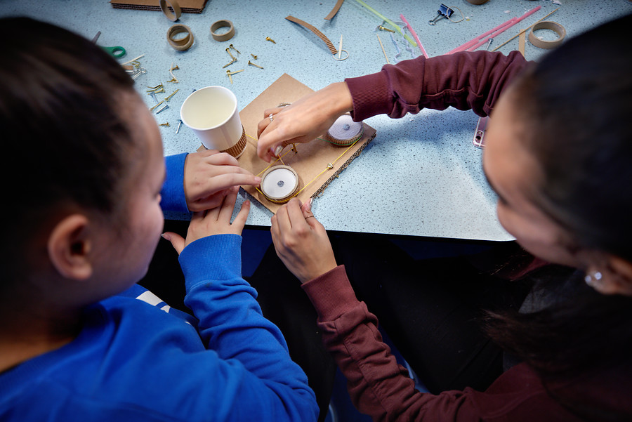

*Photography: DigiDaan*

**9. Link to curriculum:** engineering and physics