Activity 5. Gender Inclusive Science Teaching (ΝΕΜΟ)
- Learning outcome(s): (list up to 3)
    - Enhance gender awareness in science teaching.
    - Give participants an opportunity to make their teaching practice more inclusive in the future.
- Relation of activity with the STEM, gender inclusiveness and Entrepreneurship: (text, not bullets, explaining the relation of the activity to 3 above)
This workshop focuses on enhancing gender awareness in all science content and background understanding as well as overall in science teaching.
- Indicate the area of focus:
☒ STEM
☒ Gender inclusiveness
☐ Entrepreneurship
- Materials: (including ppts, videos, hands-on material)
- Photocopy of student assignments/tasks taken from science compendiums or books in your school context - for each participant. By evaluating those materials that are used frequently in your field of work you can better evaluate the materials in terms of gender inclusiveness and act on the outcome of this evaluation.
- Post-its
- Pens/pencils
- Coffee/tea and cake for break
- Flipchart
- Preparation:
The settings of the workshop can be a staff room or classroom or indeed any room where there is a possibility to make a presentation (i.e. use a projector and have a white screen). It could even be in a café kind of setting and/or a homely atmosphere that might give a more inviting atmosphere and thereby engage the participant to take part in reflection and group discussions. The room needs to enable participants to break up into smaller groups for group discussions and group tasks.
- Duration: 2X120 (minutes)
- Target group: Teachers (student age)
__________________________________________________________________________

- Description of the activity:
INTRODUCTION
The workshop starts with an introduction to the workshop explaining the objective and introducing gender and gender inclusiveness as the overall theme. Participants will be encouraged to ask questions, participate in discussions and contribute with insights from the very beginning.
DEVELOPMENT OF THE ACTIVITY
It is important here to mention that each workshop facilitator and presenter will have his or her way of presenting and conducting the different parts of the workshop. The following is an example of what can be included and how the workshop can be facilitated. The different parts included in for example the introduction will also vary from country to country and from institution to institution. This is in itself worthwhile reflecting on. Introduce gender and why it would be important to reflect on and even challenge gender stereotypes in science teaching.
This can be done using a combined PowerPoint-presentation and video statements (see YouTube link to videos below under “Useful links, videos, articles”). In preparation it is important to read and study the literature and find national or even local examples of gender inclusiveness and possibly even gender exclusiveness. These can be statistics or other examples taken from a regional or national context. Furthermore, it can be a good idea to find gender statistics on different educations. Examples of these could be statistics divided between male and female on how many of each are studying to be for example a doctor, engineer, technician or teacher. Setting up a workshop as this involves studying the literature and finding concrete examples, but at the same time it is worthwhile doing, as these kind of workshops can have a huge impact and even change the way teachers teach.
Suggested program and time schedule:
10 minutes welcome and introduction to workshop and presentation of objective (see above for objective).
30 minutes presentation (PowerPoint or other presentation and/or video) covering the following topics:
- What is gender ?
- How do we understand gender?
- Why should we spend time on gender in the classroom and in our teaching?
- Why is this important?
- Gender in science statistics.
Try and create an open atmosphere where participants feel free to pose questions in the middle of the discussion on for example the following; If they don’t want to study science – they can just study art! and then the question for discussion could be: Is it a problem that fewer girls than boys choose to follow a career in science and technology?
60 minutes reflection exercises: Present and play video statements (there are four short videos you can use for this exercise that also are texted in English - see YouTube link to videos below under “Useful links, videos, articles” on different (sometimes provocative) gender issues. These are presented by leading Danish researchers in the field of gender and education. The videos can also be ‘live statements’ that are presented during the workshop. Invite participants to discuss the statements in small groups following each video and invite them to share their thoughts in plenum. Following all 4 video statements you can take a discussion in plenum and ask Have these statements, research results and discussions changed some of your thoughts about how you teach?
20 minutes Coffee break.
45 minutes discussion: A variety of max 4 - 5 science assignments/tasks for school pupils taken from science compendiums or science books in your school context are shared with participants, who then are invited to divide into (mixed gender) groups to discuss if they found them gender inclusive or gender exclusive and why. Participants are asked to discuss what the strengths and weaknesses are of the different assignments and discuss in what ways the assignments could be improved (in relation to making them more ‘gender inclusive’).
Perspective to other ‘best practices’, 30 – 45 minutes: If possible, find an example in a commonly used science book for science subjects where you find a science assignment that you find to be especially ‘gender inclusive’. Present why you found this assignment or topic successful in being ‘gender inclusive and invite participants to share their thoughts on this. Another option is to share out different science assignments and invite participants to discuss how and where they find them to be either gender inclusive or gender exclusive. Their findings can be shared in plenum at the end of the discussions.
CONCLUSION
To conclude the workshop, you can end with an evaluation and reflective feedback. Participants are asked – again in groups – to reflect on and respond to the following 4 questions:
  - What did you like about the workshop?
  - What did you miss during the workshop?
  - What made you reflect most on your own teaching practice? And why?
  - Do you think the workshop will change your teaching practice? And if so – how?
At the very end you can invite participants to write a postcard to themselves – that you promise to send between 1 and 3 months after the workshop. Participants write down what specific things they aim to change in their own teaching practice.

USEFUL LINKS, VIDEOS, ARTICLES
• One Size fits all? is a teacher training development program developed in the framework of the TWIST project (Towards Women In Science and Technology - EU funded FP7
project).
• The Teacher Training Videos can be found on the on YouTube.
9. Link to curriculum: professional development
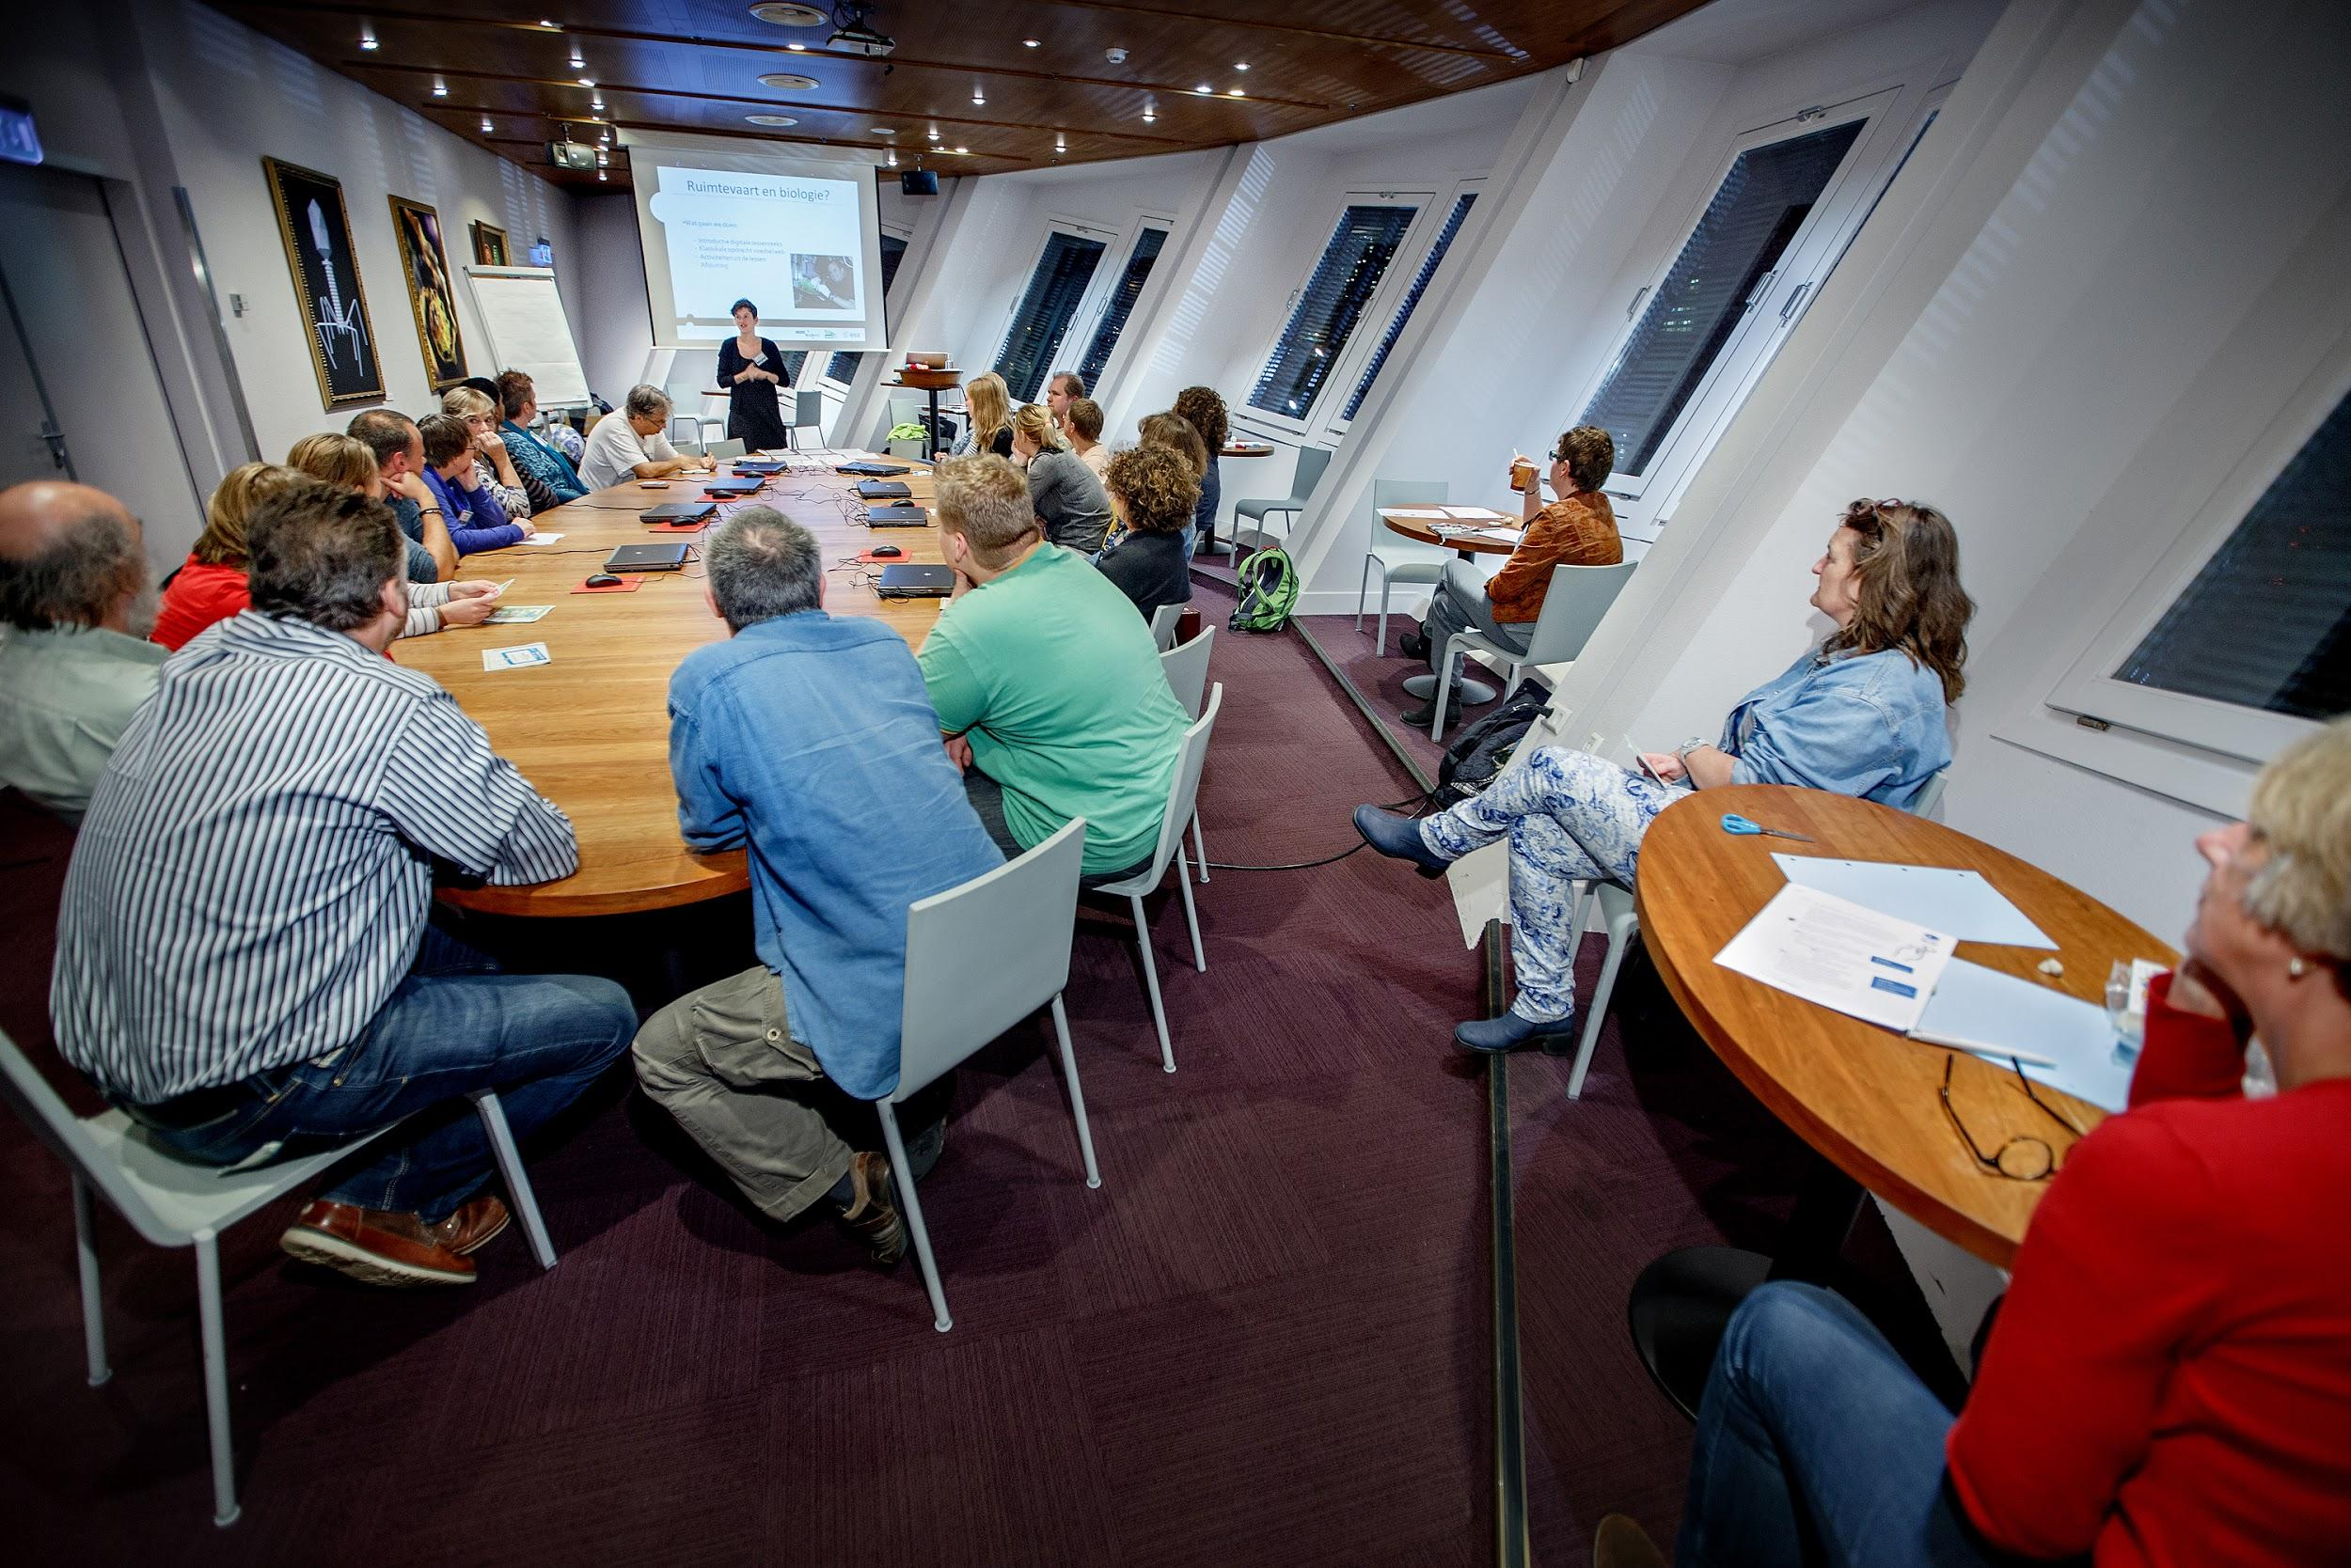

Photography: DigiDaan

