Activity 29. How is moving better? Programming an Engino Robot to navigate through a maze! (EUC)
- Learning outcome(s): (list up to 3)
    - Program a robot/car to move through a maze.
    - Identify ways to make the program easier to develop and alter by using subroutines.
- Relation of activity with the STEM, gender inclusiveness and Entrepreneurship: (text, not bullets, explaining the relation of the activity to 3 above)
STEM
- Indicate the area of focus:
☒ STEM
☐ Gender inclusiveness
☐ Entrepreneurship
- Materials: (including ppts, videos, hands-on material)
- Engino Robotics pro kits (1 kit per 3 students) (including Engino parts for the robot, instructions, and software for programming)
- Computers with the Engino Robotics software (1 PC per 3 students)
- Blocks or tape to build a maze on the floor
- Preparation:
- Duration: 60 (minutes)
- Target group: 9-14 (student age)
__________________________________________________________________________

- Description of the activity:
- Introduction
- Along with the students we build a simple maze on the floor (recommended: only 2 turns, one right and one left). We discuss with them that they need to make their robot to move in the maze without touching any walls.
- Students are reminded simple programming instructions (how to make the robot with 2 engines move on a straight line, how to turn right and how to turn left).
- Program the robot
- Students are divided in groups of 2-3, they are provided with a robot and a computer with the robotic platform
- They start programming and trying their programs, making changes whenever they are needed.
- Discussion
- After a 20-30 minute work, we get students in whole class setting and discuss difficulties they encountered. We also discuss the fact that if the maze changes, then their whole program needs to change. We discuss ways to make the programming process easier.
  - One of these, is to use the idea of subroutines, have one for moving on straight line, one moving left and another right, and use then whenever necessary.
  - Another way, it to introduce the idea of sensors (either touch or light sensors depending on the type of the maze), so that the robot can move in any type of maze.

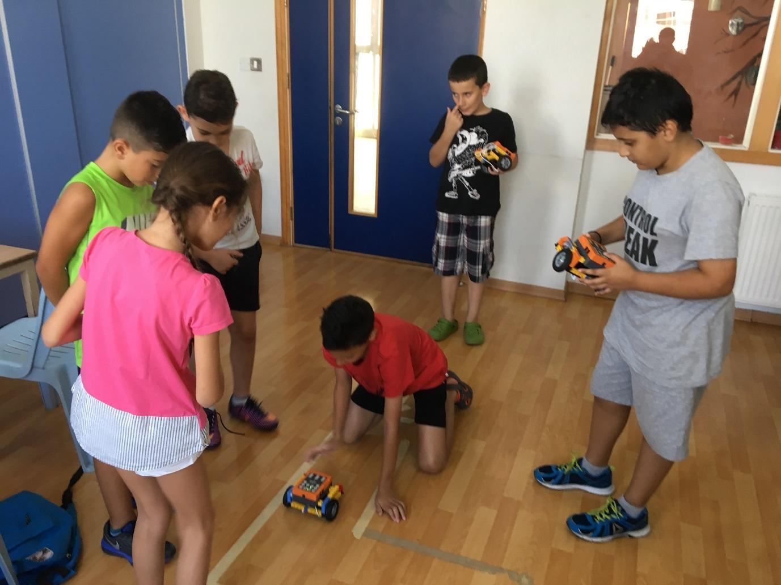
9. Link to curriculum:

